DSAA CA2 Report

Author(s): Jovan Heng, Joen Choo

Class: DAAA/FT/2A/22

Respective Adm. No. : 2401418, 2415828

User Guide

1.1 Add or Modify DASK Expressions
When users enter ‘1’ into the program, it lets them enter a DASK expression

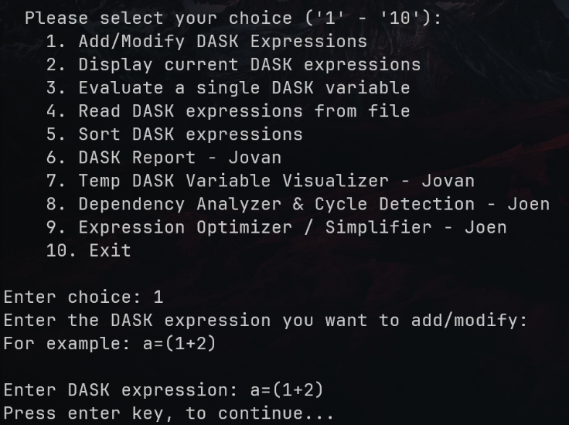
1.1.2 Constraints:
Figure 1. Terminal Usage for Option 1.
- It must be fully parenthesized expression
- Each parenthesis can only contain 2 variables

1.1.3 Operations Allowed:
- + for addition
- - for subtraction
- / for division
- * for multiplication
- ++ for summative addition
- ** for exponents
- // for summative division
User will enter an expression in the format a=exp where a is the name of the variable and exp is the fully parenthesized expression. If the variable already exists, the expression of that variable will be modified. Refer to Figure 1. for example.

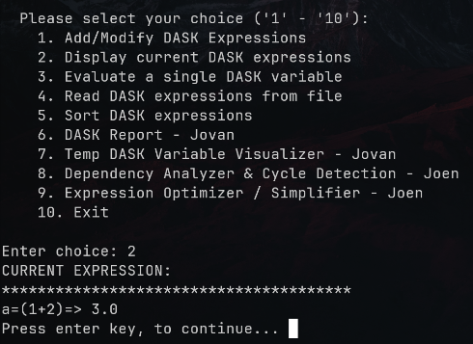
1.2 Display Current DASK Expressions
When user enters ‘2’ into the program, this will display all the currently loaded DASK expressions.
Refer to Figure 2.

1.3 Evaluate Single DASK Expression
Figure 2. Terminal Usage for Option 2
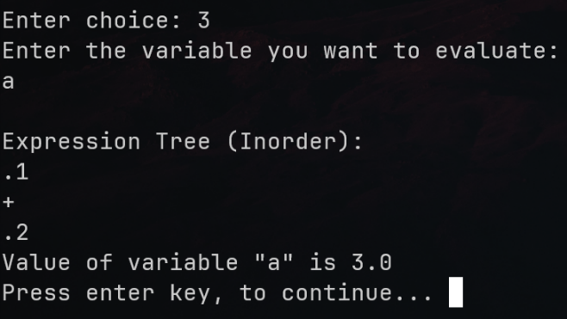
When the user enters ‘3’ into the program, it will allow the user to evaluate a single DASK Expression.
Figure 3. Terminal Usage for Option 3
The program will prompt the user to enter the variable that they want to evaluate. Upon entry of an appropriate variable, it will generate an inorder expression tree for the expression and it will compute the value of the variable.

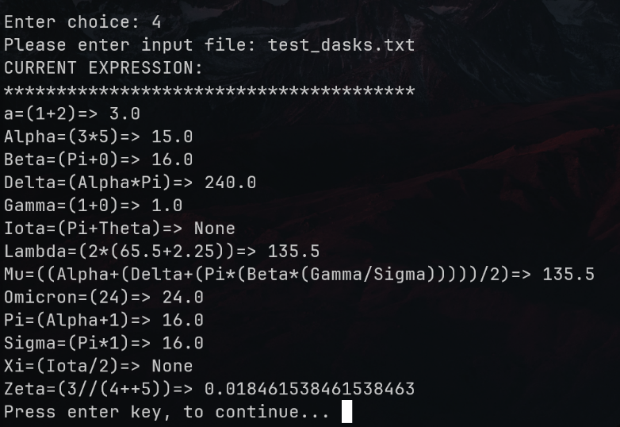
1.4 Read DASK Expressions from File
Figure 4. Terminal Usage for Option 4
When the user enters ‘4’ it allows the user to read expressions from a file.
The program will prompt the user to enter a file that contains DASK expressions. Invalid expressions from the file are skipped across. Once the file is loaded, it will show the loaded contents of the file
These DASK expressions are immediately loaded, and can be viewed, with other already loaded expressions, through the second option.

1.5 Sort DASK Expressions
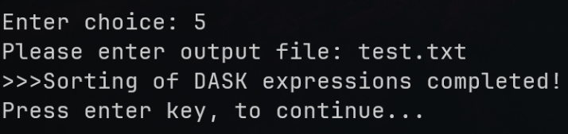
When the user enters ‘5’ it allows the user to sort the currently loaded DASK expressions via its value and output this to a file.
Figure 5. Terminal Usage for Option 5
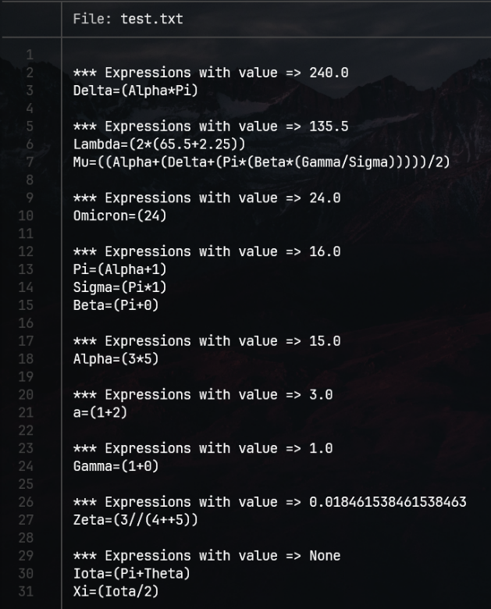
The program will prompt the user to enter an output file location. Once entered the sorting will begin, and it will inform the user when completed.
Figure 6. Output File for Option 5
Refer to Figure 6, for the output file contents, we observe that the expressions are sorted by values descending manner, and we handle the None values seamlessly.

2. Class Diagram
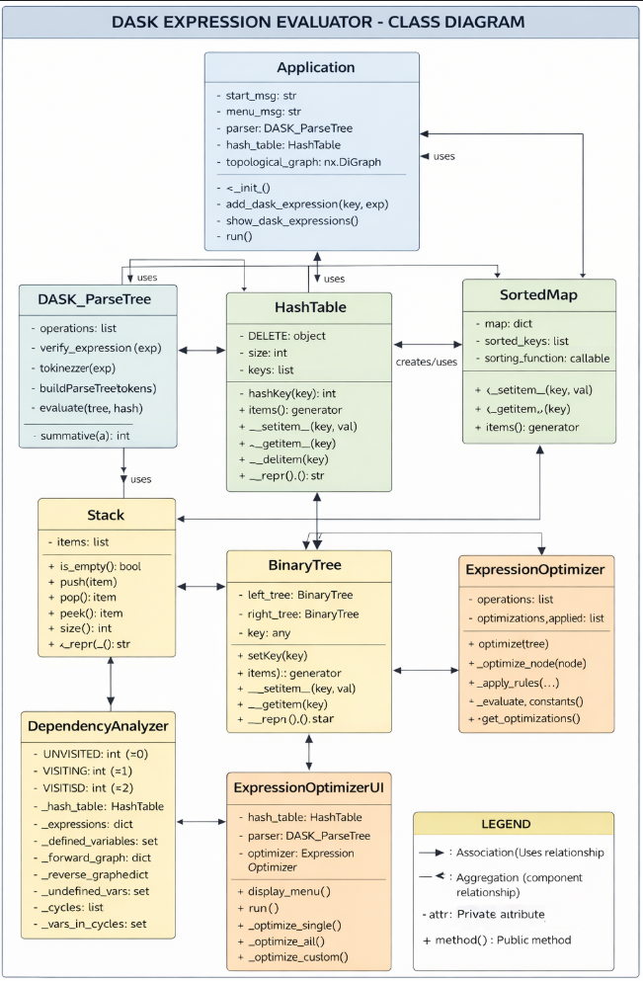
Figure 7. Class Diagram (A.I. Generated)

3. Object Oriented Programing Concepts

3.1 Encapsulation
Encapsulation is well demonstrated throughout the project by bundling data (attributes) with the methods that operate on that data:
Table 1. Summary of Encapsulation Usage
Class | Encapsulated Data | Encapsulated Methods
Binary Tree | Left_tree, right_tree, key | setKey(), getKey(), insertKey()
HashTable | keys, buckets, size | hashKey(), __setitem__(), __getitem__(), __delitem__()
Stack | items | push(), pop(), peek(), is_empty()
DependencyAnalyzer | _forward_graph, _reverse_graph, _cycles (private) | Graph traversal, cycle detection
Dask | expression, value, independent | Expression metadata storage

3.2 Operator Overloading
The project makes extensive use of Python's magic methods (dunder methods) for operator overloading:
Table 2. Summary of Operator Overloading Usage
Class | Overloaded Operator | Purpose
HashTable | __setitem__, __getitem__, __delitem__ | Enables dictionary-like syntax
HashTable | __repr__ | Custom string representation for debugging
SortedMap | __setitem__, __getitem__ | Dictionary-like access with automatic sorting
Stack | __repr__ | Custom string representation
Dask | __repr__ | Formats expression output: expression => value

3.3 Composition
The project uses composition rather than inheritance, which is a common and valid OOP design pattern:
Table 3. Summary of Composition Usage
Class | Used Classes
Application | DASK_ParseTree, HashTable, nx.DiGraph
DASK_ParseTree | Stack and creates BinaryTree objects
DependencyAnalyzerUI | DependencyAnalyzer
ExpressionOptimizerUI | ExpressionOptimizer, HashTable, and DASK_ParseTree
HashTable | Dask objects

4. Data Structures
Table 4. Summary of O(n) for classes
Data Structure | File | Purpose | Big-O Performance
BinaryTree | BinaryTree.py | Parse tree for mathematical expressions | Insert: O(h), Access: O(1), Traversal: O(n)
HashTable | HashTable.py | Store DASK variables with O(1) average lookup | Insert: O(1) avg, O(n) worst; Lookup: O(1) avg, O(n) worst; Delete: O(1) avg
Stack | Stack.py | Expression parsing and tree building | Push: O(1), Pop: O(1), Peek: O(1)
SortedMap | SortedMap.py | Alphabetically sorted variable display | Insert: O(n log n), Access: O(1), Iteration: O(n)
Dask | HashTable.py | Data object for DASK expression metadata | All operations: O(1)

5. Challenges
Class | Challenges | How to overcome
Dask_ParserTree | Had to find a way to validate DASK expressions | Implemented a Stack to help track tokens in my expression and ‘evaluating’ each expression
HashTable | Needed a good way to remove hashed values from the Table | Added Tombstoning to mark a hash a ‘empty’, effectively deleting
Nx.DiGraph | We needed a way to know which expressions to evaluate first | Used a Graph with topological sorting to give us order of evaluation.

6. Contributions
Jovan
- Options 1 and 2
- Implemented Many structures that handles DASK flawlessly
- Added validation
Joen
- Options 3 to 5
- Added Additional Features
- Cleaned up code

7. Appendix

Main.py: Jovan + Joen
import os
import networkx as nx
from structures.DASK_ParseTree import DASK_ParseTree
from structures.SortedMap import SortedMap
from structures.HashTable import HashTable, Dask
from src.get_dask_data import get_dask_data
from src.build_html import build_html
from src.clear import clear
from src.validators import input_file_path, dask_input, yes_no_input
from src.dependency_analyzer import run_dependency_analyzer
from src.expression_optimizer import run_expression_optimizer

class Application:
def __init__(self):
self.start_msg = '''
*******************************************************************************
* *
* ST1507 DSAA: DASK Expression Evaluator! *
*-----------------------------------------------------------------------------*
* - Author: Jovan Heng (2401418) & Joen Choo (2415828) *
* - Class: DAAA 2A 22 *
* *
*******************************************************************************
'''
self.menu_msg = '''
Please select your choice ('1' - '10'):
1. Add/Modify DASK Expressions
2. Display current DASK expressions
3. Evaluate a single DASK variable
4. Read DASK expressions from file
5. Sort DASK expressions
6. DASK Report - Jovan
7. Temp DASK Variable Visualizer - Jovan
8. Dependency Analyzer & Cycle Detection - Joen
9. Expression Optimizer / Simplifier - Joen
10. Exit
'''
print(self.start_msg)
print(self.menu_msg)

# We always create a parse tree object and hash table to store variables
self.parser = DASK_ParseTree()
self.hash_table = HashTable(100)
self.topological_graph = nx.DiGraph()

def add_dask_expresssion(self, key, exp):
tokens = self.parser.tokenizer(exp)

# Parse tree build and evaluate
self.hash_table[key] = Dask(expression=tokens, value=None)

# Adding to topological graph
# key relies on t
added_edges = [self.topological_graph.add_edge(t, key) for t in tokens if t.isalpha()]
# independent
if len(added_edges) == 0:
dask_obj = self.hash_table[key]
dask_obj.independent = True

# this becomes an expression that we can immediately evaluate
tree = self.parser.buildParseTree(dask_obj.expression)
value = self.parser.evaluate(tree, self.hash_table)
dask_obj.value = value

# update
self.hash_table[key] = dask_obj
return

def show_dask_expressions(self, sorting_key=lambda x: x.lower(), output=True):
# since we want to output sorted alphabetically we can use a sorted map
sorted_map = SortedMap(sorting_function=sorting_key)

if output:
print('CURRENT EXPRESSION:')
print('***************************************')

# print the independent ones first
for var, dask_obj in self.hash_table.items():
if dask_obj.independent:
sorted_map[var] = dask_obj

# iteratively calcuate
sorted_graph = list(nx.topological_sort(self.topological_graph))
for var in sorted_graph:
dask_obj = self.hash_table[var]
if dask_obj == None:
# skip the ones that dont exist
continue

if dask_obj.independent:
# skip independent ones
continue

# calcuate value
tree = self.parser.buildParseTree(dask_obj.expression)
value = self.parser.evaluate(tree, self.hash_table)

# Update the dask thingy
dask_obj.value = value
self.hash_table[var] = dask_obj

# add to sorted map
sorted_map[var] = dask_obj

# output all
if output:
for var, dask_obj in sorted_map.items():
print(f'{var}={dask_obj}')
return sorted_map

def run(self):
#################################
# Main Loop Recursive
#################################
choice = input("Enter choice: ")

if choice == '10':
return
# Expression Storing/Modify
if choice == '1':
print("Enter the DASK expression you want to add/modify:")
print("For example: a=(1+2)\n")
key, exp = dask_input("Enter DASK expression: ")
self.add_dask_expresssion(key, exp)

# evaluuation
elif choice == '2':
self.show_dask_expressions()
# evaluate single expression from hash
elif choice == '3':
print("Enter the variable you want to evaluate:")
var = input().strip()
dask_obj = self.hash_table[var]
# validate proper variable
while dask_obj == None:
print(f'Variable {var} does not exist!')
print('Please enter another variable: \n')
var = input().strip()
dask_obj = self.hash_table[var]

tree = self.parser.buildParseTree(dask_obj.expression)
value = self.parser.evaluate(tree, self.hash_table)

print('\nExpression Tree (Inorder):')
tree.print_tree_inorder()
print(f'Value of variable "{var}" is {value}')

# read from file and add dask to table
elif choice == '4':
filename = input_file_path("Please enter input file: ")

with open(filename, 'r') as f:
lines = f.readlines()

for line in lines:
key , exp = line.strip().split('=', 1)

# skip invalid expressions
if not self.parser.verify_expression(exp):
print(f'Invalid DASK for {key} = {exp}. Skipping...')
continue

self.add_dask_expresssion(key, exp)
f.close()

# print current expressions
self.show_dask_expressions()

# sort expressions based on result values
elif choice == '5':
filename = input("Please enter output file: ")
sorted_map = self.show_dask_expressions(sorting_key=lambda x: -self.hash_table[x].value if self.hash_table[x].value != None else float('inf'), output=False)
with open(filename, 'w') as f:
prev = float('-inf')
for var, dask_obj in sorted_map.items():
if dask_obj.value != prev:
f.write(f'\n*** Expressions with value => {dask_obj.value}\n')
prev = dask_obj.value

exp_str = ''.join(dask_obj.expression)
f.write(f'{var}={exp_str}\n')
f.close()

print('>>>Sorting of DASK expressions completed!')

# Jovan - DASK Report
elif choice == '6':
output_path = input("Please enter output HTML file path: ")

while output_path.strip() == '' or not output_path.lower().endswith('.html'):
print('That is not a valid HTMl path. Please try again!\n')
output_path = input("Please enter output HTML file path: ")

# get data
data = get_dask_data(self.topological_graph, self.show_dask_expressions(output=False), self.parser.buildParseTree)

# build html
build_html(data, output_path)

print(f'DASK Report generated successfully at {output_path}!')

# query open
open_query = yes_no_input('Do you want to open the report now? (y/n): ')

if open_query.lower() == 'y':
os.startfile(output_path)

# Jovan - Temp DASK Variable Visualizer
elif choice == '7':
clear()
self.show_dask_expressions()
print('\nPlease enter expressions to visualize DASK Variables (q to quit):')
expression = 0
pending_keys = []

while expression != 'q':
key , expression = dask_input("Enter DASK expression: ", allow_quit=True)

# add dask 'temp'
pending_keys.append(key)
self.add_dask_expresssion(key, expression)
clear()

# custom print
sorted_map = self.show_dask_expressions(output=False)
for var, dask_obj in sorted_map.items():
if var in pending_keys:
print(f'***{var}={dask_obj}***')
else:
print(f'{var}={dask_obj}')

# reprompt
print('\nPlease enter expressions to visualize DASK Variables (q to quit):')
key, expression = dask_input("Enter DASK expression: ", allow_quit=True)

# show 'pending' expressions to add
if len(pending_keys) > 0:
print('\nThe following expressions were not added:')
print('***********************************************')
for pk in pending_keys:
dask_obj = self.hash_table[pk]
print(f'{pk}={dask_obj}')

add_expressions = yes_no_input('Do you want to add these expressions? (y/n): ')

if add_expressions.lower() == 'n':
# remove since theyre alr stored
for pk in pending_keys:
del self.hash_table[pk]

# handle graph edges
if pk in self.topological_graph:
self.topological_graph.remove_node(pk)
clear()

# Dependency Analyzer & Cycle Detection (unified feature)
elif choice == '8':
run_dependency_analyzer(self.hash_table)

# Expression Optimizer / Simplifier
elif choice == '9':
run_expression_optimizer(self.hash_table, self.parser)

# invalid
else:
print('That is not a valid choice. Please try again.')

# re-input
input('Press enter key, to continue... ')
print(self.menu_msg)
self.run()

# psvm

if __name__ == '__main__':
app = Application()
app.run()

BinaryTree.py Jovan
class BinaryTree:
def __init__(self, key, left=None, right=None):
self.left_tree = left
self.right_tree = right
self.key = key

def setKey(self, key):
self.key = key
return

def getKey(self):
return self.key

def getLeftTree(self):
return self.left_tree

def getRightTree(self):
return self.right_tree

def insertLeft(self, tree):
if self.left_tree == None:
self.left_tree = tree

else:
# there alr is a tree
self.left_tree.insertLeft(tree)

return

def insertRight(self , tree):
if self.right_tree == None:
self.right_tree = tree
else:
self.right_tree.insertRight(tree)
return

def print_tree_inorder(self, level=0):
if self.getLeftTree() is not None:
self.getLeftTree().print_tree_inorder(level + 1)

print('.' * level + str(self.getKey()))

if self.getRightTree() is not None:
self.getRightTree().print_tree_inorder(level + 1)

DASK_ParseTree.py: Jovan
from structures.BinaryTree import BinaryTree
from structures.Stack import Stack

class DASK_ParseTree:
def __init__(self):
self.operations = ['+' , '-' , '/' , '*' , '**' , '++' , '//']

def verify_expression(self, exp):
'''
Returns False if bad, True if ok
'''
tokens = self.tokenizer(exp)
stack = Stack()
for t in tokens:

if t == ')':
# we backtrack the stack
if stack.is_empty():
return False

exp_group = []
while not stack.is_empty():
top = stack.pop()

if top == '(':
break
else:
exp_group.append(top)

else:
# we didnt find a matching (
return False

exp_group.reverse()
# now we have a expression group
# since we are dealing with binary trees the only exp check is len(3), start end in brackets, 2 values. mid is operator

if len(exp_group) == 1 and (exp_group[0].isalpha() or exp_group[0].replace('.','',1).isdigit()):
# single value expression ok
stack.push('EXP')
continue

if len(exp_group) != 3:
return False
# operator
if exp_group[1] not in self.operations:
return False
# values
if not (exp_group[0].isalpha() or exp_group[0].replace('.','',1).isdigit()):
return False
if not (exp_group[2].isalpha() or exp_group[2].replace('.','',1).isdigit()):
return False

# push a placeholder variabel
stack.push('EXP')

else:
stack.push(t)

# we should end with 'EXP' only
return stack.size() == 1 and stack.pop() == 'EXP'

def summative(self , a ):
return a * ( a + 1 ) // 2

def tokenizer(self , exp):
tokens = []
for i in exp:
if i in ['(' , ')']:
tokens.append(i)

elif i in self.operations:
if len(tokens) > 0 and tokens[-1] in self.operations:
# build token if multi-char operator
tokens[-1] = tokens[-1] + i
else:
# single char
tokens.append(i)

# All same logic as above
elif i.isdigit() or i == '.':
if len(tokens) > 0 and (tokens[-1].isdigit() or '.' in tokens[-1]):
tokens[-1] = tokens[-1] + i
else:
tokens.append(i)

elif i.isalpha():
if len(tokens) > 0 and tokens[-1].isalpha():
tokens[-1] = tokens[-1] + i
else:
tokens.append(i)

else:
# not a char what we want
continue
return tokens

def buildParseTree(self, tokens):
# Just a check for single value expressions like (42) or (Pi)
if len(tokens) == 3:
# since all exps are paranthesized we just need to check len = 3
return BinaryTree(tokens[1])

tree = BinaryTree('?')
stack = Stack()
stack.push(tree)

currentTree = tree

for t in tokens:
if t == '(':
next_branch = BinaryTree('?')
currentTree.insertLeft(next_branch)
stack.push(currentTree)
currentTree = next_branch
elif t in self.operations:
currentTree.setKey(t)
right_branch = BinaryTree('?')
currentTree.insertRight(right_branch)
stack.push(currentTree)
currentTree = right_branch
elif t == ')':
currentTree = stack.pop()
else:
currentTree.setKey(t)
currentTree = stack.pop()

return tree

def evaluate(self , tree, hash_table):
# post traversal
leftTree = tree.getLeftTree()
rightTree = tree.getRightTree()
op = tree.getKey()

# main evaluation
if leftTree != None and rightTree != None:
left_val = self.evaluate(leftTree, hash_table)
if left_val is None:
return None

right_val = self.evaluate(rightTree, hash_table)
if right_val is None:
return None

if op == '+':
return left_val + right_val
if op == '-':
return left_val - right_val
if op == '/':
return left_val / right_val
if op == '*':
return left_val * right_val
if op == '**':
return left_val ** right_val
if op == '++':
return self.summative(left_val) + self.summative(right_val)
if op == '//':
return self.summative(left_val) / self.summative(right_val)

return None # unknown operator

# there is left right expression that evals to None and current is op
if op in self.operations:
return None

if op.isalpha():
# query variable value from table
return hash_table[op].value if hash_table[op] != None else None

return float(op)

if __name__ == '__main__':
exp = "((a + b) * (c - d))"
exp = "(24)"
parser = DASK_ParseTree()
tokens = parser.tokenizer(exp)
print("Is expression valid? ", parser.verify_expression(tokens))

Hashtable.py Jovan:
class Dask:
def __init__(self, expression, value, independent=False):
self.expression = expression
self.value = value
self.independent = independent
def __repr__(self):
return f'{"".join(self.expression)}=> {self.value}'

class HashTable:
DELETE = object() # tombstone marker for deletion

def __init__(self , size):
self.size = size
self.keys = [None] * size
self.buckets= [None] * size

# this returns a index in my self.keys
def hashKey(self , key):
if isinstance(key , str):
hash_sum = 0
for char in key:
hash_sum += ord(char)
else:
# just int key
hash_sum = key

# idk where i found this formula
return hash_sum % self.size

def items(self):
return ((k, v) for k, v in zip(self.keys, self.buckets) if k is not None and k != HashTable.DELETE)

def __setitem__(self , key , value):
index = self.hashKey(key)
start_index = index

while True:
# if empty we just use
if self.keys[index] == None or self.keys[index] == HashTable.DELETE:
# assign the key to this index (hash)
# assign value to same index
self.keys[index] = key
self.buckets[index] = value
break

# overwrite if same
elif self.keys[index] == key:
self.buckets[index] = value
break

# Find new key (we have hash collision)
else:
index = self.hashKey(index + 1) # +1 for linear progression

if index == start_index:
# here we have considered the entire table
# we litterally cannot accomodate for any more key-value-pairs
break

def __getitem__(self, key):
# same idea of hashing and going over entire keys list
index = self.hashKey(key)

start_index = index

while True:
if self.keys[index] == None:
return None # key doesn't exist early exit

if self.keys[index] == key:
return self.buckets[index]

# there was collision during entry so we have to linearly cycle to the key
else:
index = self.hashKey(index + 1)

if index == start_index:
return None

def __delitem__(self , key):
index = self.hashKey(key)
start_index = index

while True:
if self.keys[index] == key:
# mark as deleted
self.keys[index] = HashTable.DELETE
self.buckets[index] = None
break

else:
index = self.hashKey(index + 1)

# this key doesn't exist
if index == start_index:
break

def __repr__(self):
output_string = "{"
for k, v in zip(self.keys, self.buckets):
output_string += f'\n\t{k}: {v}'
return output_string + "\n}"

if __name__ == '__main__':
# simple test
ht = HashTable(5)
names = ['apple', 'banana', 'grape', 'orange', 'mango', 'peach']
for i, name in enumerate(names):
ht[name] = i

print(ht)
del ht['banana']
del ht['orange']
print(ht)

SortedMap.py Joen:
class SortedMap:
def __init__(self, sorting_function=None):
self.map = {}
self.sorted_keys = []
self.sorting_function = sorting_function

def __setitem__(self, key, value):
# sort regardless of capitalization
if key not in self.map:
self.sorted_keys.append(key)
if self.sorting_function:
self.sorted_keys.sort(key=self.sorting_function)
else:
self.sorted_keys.sort()
self.map[key] = value

def __getitem__(self, key):
return self.map[key]

def items(self):
for key in self.sorted_keys:
yield (key, self.map[key])

Stack.py Joen:
class Stack:
def __init__(self):
self.items = []

def is_empty(self):
return len(self.items) == 0

def push(self, item):
self.items.append(item)

def pop(self):
if not self.is_empty():
return self.items.pop()
raise IndexError("pop from empty stack")

def peek(self):
if not self.is_empty():
return self.items[-1]
raise IndexError("peek from empty stack")

def size(self):
return len(self.items)

def __repr__(self):
return f'Stack({self.items})'

build_html.py Jovan:
import json
def build_html(data, output_path):
with open('templates/template.html' , 'r') as f:
template = f.read()
template = template.replace('/*<mock_data>*/', json.dumps(data)[1:-1]) # indexing removes start end {}

with open(output_path, 'w') as out_file:
out_file.write(template)

clear.py Jovan:
import os
def clear():
if os.name == 'nt':
os.system('cls')
else:
os.system('clear')

dependency_analyzer.py Joen:
class DependencyAnalyzer:
"""Unified dependency analyzer with forward/reverse graphs and cycle detection."""

# DFS vertex states for cycle detection
UNVISITED = 0
VISITING = 1
VISITED = 2

def __init__(self, hash_table=None, expressions=None):
"""Initialize with either hash_table or expressions dict."""
self._hash_table = hash_table
self._expressions = expressions # dict of var -> expression string
self._defined_variables = set()
self._forward_graph = {}
self._reverse_graph = {}
self._undefined_vars = None
self._cycles = None
self._vars_in_cycles = None
self._build_graphs()

def _build_graphs(self):
"""Build both forward and reverse dependency graphs."""
# Build forward graph from hash_table or expressions dict
if self._hash_table is not None:
for variable, dask_obj in self._hash_table.items():
if dask_obj is not None:
dependencies = self._extract_dependencies(dask_obj.expression)
dependencies.discard(variable)

self._defined_variables.add(variable)
self._forward_graph[variable] = dependencies

for dep in dependencies:
if dep not in self._forward_graph:
self._forward_graph[dep] = set()
elif self._expressions is not None:
for variable, expr_tokens in self._expressions.items():
dependencies = self._extract_dependencies(expr_tokens)
dependencies.discard(variable)

self._defined_variables.add(variable)
self._forward_graph[variable] = dependencies

for dep in dependencies:
if dep not in self._forward_graph:
self._forward_graph[dep] = set()

# Build reverse graph (transpose)
for var in self._forward_graph:
self._reverse_graph[var] = set()

for var, deps in self._forward_graph.items():
for dep in deps:
if dep not in self._reverse_graph:
self._reverse_graph[dep] = set()
self._reverse_graph[dep].add(var)

@staticmethod
def _extract_dependencies(tokens):
"""Extract variable dependencies from expression tokens."""
return {token for token in tokens if token.isalpha()}

def get_dependencies(self, variable):
"""Get direct dependencies of a variable."""
return self._forward_graph.get(variable, set()).copy()

def get_all_dependencies(self, variable):
"""Get all dependencies using BFS (transitive closure)."""
if variable not in self._forward_graph:
return set()

visited = set()
queue = list(self._forward_graph.get(variable, set()))

while queue:
current = queue.pop(0)
if current not in visited:
visited.add(current)
queue.extend(self._forward_graph.get(current, set()) - visited)

return visited

def get_dependents(self, variable):
"""Get direct dependents of a variable."""
return self._reverse_graph.get(variable, set()).copy()

def get_all_dependents(self, variable):
"""Get all dependents with distances using BFS."""
if variable not in self._reverse_graph:
return set(), {}

visited = set()
levels = {}
queue = [(variable, 0)]

while queue:
current, level = queue.pop(0)

for dependent in self._reverse_graph.get(current, set()):
if dependent not in visited:
visited.add(dependent)
levels[dependent] = level + 1
queue.append((dependent, level + 1))

return visited, levels

def detect_cycles(self):
"""Detect all cycles using DFS with vertex coloring."""
if self._cycles is not None:
return self._vars_in_cycles, self._cycles

state = {node: self.UNVISITED for node in self._forward_graph}
self._vars_in_cycles = set()
self._cycles = []

def dfs(node, path):
state[node] = self.VISITING

for neighbor in self._forward_graph.get(node, set()):
if neighbor not in state:
continue

if state[neighbor] == self.VISITING:
cycle = self._reconstruct_cycle(path, neighbor)
self._cycles.append(cycle)
self._vars_in_cycles.update(cycle[:-1])

elif state[neighbor] == self.UNVISITED:
dfs(neighbor, path + [neighbor])

state[node] = self.VISITED

for node in self._forward_graph:
if state[node] == self.UNVISITED:
dfs(node, [node])

return self._vars_in_cycles, self._cycles

def _reconstruct_cycle(self, path, cycle_start):
"""Reconstruct cycle path from DFS traversal."""
try:
start_idx = path.index(cycle_start)
return path[start_idx:] + [cycle_start]
except ValueError:
return [cycle_start, path[-1], cycle_start]

def get_undefined_variables(self):
"""Find variables referenced but never defined."""
if self._undefined_vars is not None:
return self._undefined_vars

all_referenced = set()
for deps in self._forward_graph.values():
all_referenced.update(deps)

self._undefined_vars = all_referenced - self._defined_variables
return self._undefined_vars

def get_defined_variables(self):
return self._defined_variables.copy()

def get_total_variables(self):
return len(self._defined_variables)

def get_total_edges(self):
return sum(len(deps) for deps in self._forward_graph.values())

def has_cycles(self):
_, cycles = self.detect_cycles()
return len(cycles) > 0

def has_undefined(self):
return len(self.get_undefined_variables()) > 0

def variable_exists(self, variable):
return variable in self._defined_variables

def variable_is_referenced(self, variable):
return variable in self._forward_graph

def get_expression_string(self, variable):
if self._hash_table is not None:
dask_obj = self._hash_table[variable]
if dask_obj:
return ''.join(dask_obj.expression)
elif self._expressions is not None:
if variable in self._expressions:
return ''.join(self._expressions[variable])
return "?"

class DependencyAnalyzerUI:
"""User interface for the Dependency Analyzer."""

SUBMENU = """
+==============================================================+
| DEPENDENCY ANALYZER - SUB MENU |
+==============================================================+
| 1. View all variable dependencies |
| 2. Check for undefined variables |
| 3. Query: What does variable X depend on? |
| 4. Query: What depends on variable X? (reverse) |
| 5. Full analysis report |
| 6. Load & analyze from file (supports cycles) |
| 7. Return to main menu |
+==============================================================+
"""

def __init__(self, hash_table):
self._hash_table = hash_table
self._analyzer = None

def run(self):
self._analyzer = DependencyAnalyzer(self._hash_table)
self._print_header()

while True:
print(self.SUBMENU)
choice = input(" Enter choice (1-7): ").strip()

if choice == '1':
self._show_all_dependencies()
elif choice == '2':
self._show_undefined_variables()
elif choice == '3':
self._query_forward_dependencies()
elif choice == '4':
self._query_reverse_dependencies()
elif choice == '5':
self._show_full_report()
elif choice == '6':
self._load_and_analyze_file()
elif choice == '7':
print("\n Returning to main menu...\n")
break
else:
print("\n Invalid choice. Please enter 1-9.\n")

input("\n Press Enter to continue...")

def _print_header(self):
print("\n" + "=" * 64)
print(" DEPENDENCY ANALYZER & CYCLE DETECTOR")
print("=" * 64)
print(f" Variables loaded: {self._analyzer.get_total_variables()}")
print(f" Dependency edges: {self._analyzer.get_total_edges()}")
print("=" * 64)

def _print_section(self, title):
print(f"\n {'-' * 56}")
print(f" {title}")
print(f" {'-' * 56}")

def _show_all_dependencies(self):
self._print_section("ALL VARIABLE DEPENDENCIES")

defined_vars = sorted(self._analyzer.get_defined_variables(), key=str.lower)

if not defined_vars:
print(" No variables defined.")
return

for var in defined_vars:
deps = self._analyzer.get_dependencies(var)
exp_str = self._analyzer.get_expression_string(var)

if deps:
deps_str = ", ".join(sorted(deps, key=str.lower))
print(f" {var} = {exp_str}")
print(f" --> depends on: {deps_str}")
else:
print(f" {var} = {exp_str}")
print(f" --> (independent - no dependencies)")

def _show_undefined_variables(self):
self._print_section("UNDEFINED VARIABLE CHECK")

undefined = self._analyzer.get_undefined_variables()

if not undefined:
print(" [OK] All referenced variables are defined!")
return

print(f" [WARNING] Found {len(undefined)} undefined variable(s):\n")

for var in sorted(undefined, key=str.lower):
referencing = []
for defined_var in self._analyzer.get_defined_variables():
if var in self._analyzer.get_dependencies(defined_var):
referencing.append(defined_var)

print(f" - '{var}' is referenced by: {', '.join(referencing)}")

def _query_forward_dependencies(self):
self._print_section("FORWARD DEPENDENCY QUERY")

var = input(" Enter variable name: ").strip()

if not var:
print(" No variable entered.")
return

if not self._analyzer.variable_exists(var):
if self._analyzer.variable_is_referenced(var):
print(f" '{var}' is referenced but not defined.")
else:
print(f" Variable '{var}' not found.")
return

exp_str = self._analyzer.get_expression_string(var)
print(f"\n {var} = {exp_str}")

direct = self._analyzer.get_dependencies(var)
print(f"\n Direct dependencies ({len(direct)}):")
if direct:
for dep in sorted(direct, key=str.lower):
status = "[DEFINED]" if self._analyzer.variable_exists(dep) else "[UNDEFINED]"
print(f" - {dep} {status}")
else:
print(" (none - this is an independent variable)")

all_deps = self._analyzer.get_all_dependencies(var)
indirect = all_deps - direct

if indirect:
print(f"\n Indirect dependencies ({len(indirect)}):")
for dep in sorted(indirect, key=str.lower):
status = "[DEFINED]" if self._analyzer.variable_exists(dep) else "[UNDEFINED]"
print(f" - {dep} {status}")

print(f"\n Total: {len(all_deps)} dependency(ies)")

def _query_reverse_dependencies(self):
self._print_section("REVERSE DEPENDENCY QUERY")

var = input(" Enter variable name: ").strip()

if not var:
print(" No variable entered.")
return

if not self._analyzer.variable_exists(var):
if self._analyzer.variable_is_referenced(var):
print(f" '{var}' is referenced but not defined.")
else:
print(f" Variable '{var}' not found.")
return

exp_str = self._analyzer.get_expression_string(var)
print(f"\n Query: What depends on '{var}'?")
print(f" {var} = {exp_str}")

direct = self._analyzer.get_dependents(var)
print(f"\n Direct dependents ({len(direct)}):")
if direct:
for dep in sorted(direct, key=str.lower):
dep_exp = self._analyzer.get_expression_string(dep)
print(f" - {dep} = {dep_exp}")
else:
print(" (none - this is a leaf variable)")

all_deps, levels = self._analyzer.get_all_dependents(var)

if all_deps - direct:
max_level = max(levels.values()) if levels else 0
for lvl in range(2, max_level + 1):
vars_at_level = sorted([v for v, l in levels.items() if l == lvl], key=str.lower)
if vars_at_level:
print(f"\n Level {lvl} dependents ({len(vars_at_level)}):")
for dep in vars_at_level:
dep_exp = self._analyzer.get_expression_string(dep)
print(f" - {dep} = {dep_exp}")

print(f"\n Impact Summary:")
print(f" If '{var}' changes, {len(all_deps)} variable(s) would need re-evaluation")
if all_deps:
print(f" Affected: {', '.join(sorted(all_deps, key=str.lower))}")

def _show_full_report(self):
self._print_section("FULL DEPENDENCY ANALYSIS REPORT")

# Stats
print(f"\n STATISTICS")
print(f" {'.' * 50}")
print(f" Total variables defined: {self._analyzer.get_total_variables()}")
print(f" Total dependency edges: {self._analyzer.get_total_edges()}")

undefined = self._analyzer.get_undefined_variables()
print(f" Undefined references: {len(undefined)}")

vars_in_cycles, cycles = self._analyzer.detect_cycles()
print(f" Cycles detected: {len(cycles)}")
print(f" Variables in cycles: {len(vars_in_cycles)}")

# Health check
print(f"\n HEALTH CHECK")
print(f" {'.' * 50}")

if not undefined and not cycles:
print(" [OK] Graph is healthy - all expressions can be evaluated!")
else:
if undefined:
print(f" [!] Undefined variables: {', '.join(sorted(undefined, key=str.lower))}")
if cycles:
print(f" [!] Circular references detected in: {', '.join(sorted(vars_in_cycles, key=str.lower))}")

# Dependency overview
print(f"\n DEPENDENCY OVERVIEW")
print(f" {'.' * 50}")

independent = [v for v in self._analyzer.get_defined_variables()
if not self._analyzer.get_dependencies(v)]
if independent:
print(f" Independent (base) variables: {', '.join(sorted(independent, key=str.lower))}")

leaves = [v for v in self._analyzer.get_defined_variables()
if not self._analyzer.get_dependents(v)]
if leaves:
print(f" Leaf (output) variables: {', '.join(sorted(leaves, key=str.lower))}")

max_deps = 0
most_deps = []
for var in self._analyzer.get_defined_variables():
deps = len(self._analyzer.get_dependencies(var))
if deps > max_deps:
max_deps = deps
most_deps = [var]
elif deps == max_deps and deps > 0:
most_deps.append(var)

if most_deps and max_deps > 0:
print(f" Most dependencies ({max_deps}): {', '.join(sorted(most_deps, key=str.lower))}")

max_dependents = 0
most_dependents = []
for var in self._analyzer.get_defined_variables():
deps, _ = self._analyzer.get_all_dependents(var)
if len(deps) > max_dependents:
max_dependents = len(deps)
most_dependents = [var]
elif len(deps) == max_dependents and len(deps) > 0:
most_dependents.append(var)

if most_dependents and max_dependents > 0:
print(f" Most impact ({max_dependents} affected): {', '.join(sorted(most_dependents, key=str.lower))}")

def _load_and_analyze_file(self):
"""Load expressions from file and analyze (supports cycles)."""
self._print_section("LOAD & ANALYZE FROM FILE")

print(" This loads expressions directly for analysis without")
print(" adding them to the main program (supports cycles).\n")

filepath = input(" Enter file path: ").strip()

if not filepath:
print(" No file path entered.")
return

try:
with open(filepath, 'r') as f:
lines = f.readlines()
except FileNotFoundError:
print(f" File not found: {filepath}")
return
except Exception as e:
print(f" Error reading file: {e}")
return

# Parse expressions from file
expressions = {}
for line in lines:
line = line.strip()
if not line or line.startswith('#') or '=' not in line:
continue

key, exp = line.split('=', 1)
key = key.strip()
# Simple tokenizer for dependencies
tokens = []
current = ''
for char in exp:
if char.isalpha():
current += char
else:
if current:
tokens.append(current)
current = ''
if current:
tokens.append(current)
expressions[key] = tokens

if not expressions:
print(" No valid expressions found in file.")
return

# Create analyzer for file expressions
file_analyzer = DependencyAnalyzer(expressions=expressions)

print(f"\n Loaded {len(expressions)} expressions from file.")
print(f" Dependency edges: {file_analyzer.get_total_edges()}")

# Check for cycles
vars_in_cycles, cycles = file_analyzer.detect_cycles()

print(f"\n CYCLE DETECTION RESULTS")
print(f" {'.' * 50}")

if cycles:
print(f" [WARNING] Found {len(cycles)} cycle(s)!")
print(f" Variables in cycles: {len(vars_in_cycles)}")

print("\n Cycle paths:")
for i, cycle in enumerate(cycles, 1):
cycle_str = " -> ".join(cycle)
print(f" {i}. {cycle_str}")

print(f"\n Variables involved:")
for var in sorted(vars_in_cycles, key=str.lower):
exp_str = file_analyzer.get_expression_string(var)
print(f" - {var} = {exp_str}")
else:
print(" [OK] No circular dependencies detected!")

# Check for undefined
undefined = file_analyzer.get_undefined_variables()
if undefined:
print(f"\n UNDEFINED VARIABLES")
print(f" {'.' * 50}")
print(f" Found {len(undefined)}: {', '.join(sorted(undefined, key=str.lower))}")

# Show all dependencies
print(f"\n ALL DEPENDENCIES")
print(f" {'.' * 50}")
for var in sorted(file_analyzer.get_defined_variables(), key=str.lower):
deps = file_analyzer.get_dependencies(var)
exp_str = file_analyzer.get_expression_string(var)
if deps:
print(f" {var} = {exp_str}")
print(f" --> depends on: {', '.join(sorted(deps, key=str.lower))}")
else:
print(f" {var} = {exp_str}")
print(f" --> (independent)")

def run_dependency_analyzer(hash_table):
"""Main entry point for the dependency analyzer feature."""
ui = DependencyAnalyzerUI(hash_table)
ui.run()

expression_optimizer.py Joen:
from structures.BinaryTree import BinaryTree
from structures.Stack import Stack

class ExpressionOptimizer:
"""Optimizes and simplifies DASK expressions using algebraic rules."""

def __init__(self):
self.operations = ['+', '-', '/', '*', '**', '++', '//']
self.optimizations_applied = []

def optimize(self, tree):
"""Main optimization method. Returns an optimized copy of the tree."""
self.optimizations_applied = []
return self._optimize_node(tree)

def _optimize_node(self, node):
"""Recursively optimize using post-order traversal."""
if node is None:
return None

left = node.getLeftTree()
right = node.getRightTree()
op = node.getKey()

# Leaf node - return as-is
if left is None and right is None:
return BinaryTree(op)

# Optimize subtrees first (post-order)
optimized_left = self._optimize_node(left)
optimized_right = self._optimize_node(right)

return self._apply_rules(op, optimized_left, optimized_right)

def _is_number(self, value):
try:
float(value)
return True
except (ValueError, TypeError):
return False

def _get_number(self, value):
return float(value)

def _is_leaf(self, node):
return node.getLeftTree() is None and node.getRightTree() is None

def _get_leaf_value(self, node):
if self._is_leaf(node):
return node.getKey()
return None

def _create_number_node(self, value):
if value == int(value):
return BinaryTree(str(int(value)))
return BinaryTree(str(value))

def _summative(self, n):
"""Calculate the summative of n: ∑n = n + (n-1) + ... + 1 = n*(n+1)/2"""
n = int(n)
return n * (n + 1) / 2

def _apply_rules(self, op, left, right):
"""Apply algebraic simplification rules."""
left_val = self._get_leaf_value(left)
right_val = self._get_leaf_value(right)

left_is_num = self._is_number(left_val) if left_val else False
right_is_num = self._is_number(right_val) if right_val else False

# Constant Folding
if left_is_num and right_is_num:
result = self._evaluate_constants(op, self._get_number(left_val), self._get_number(right_val))
if result is not None:
self.optimizations_applied.append(f"Constant folding: ({left_val} {op} {right_val}) => {result}")
return self._create_number_node(result)

# Addition identity rules
if op == '+':
if right_is_num and self._get_number(right_val) == 0:
self.optimizations_applied.append(f"Identity: ({left_val or 'expr'} + 0) => {left_val or 'expr'}")
return left
if left_is_num and self._get_number(left_val) == 0:
self.optimizations_applied.append(f"Identity: (0 + {right_val or 'expr'}) => {right_val or 'expr'}")
return right

# Subtraction rules
if op == '-':
if right_is_num and self._get_number(right_val) == 0:
self.optimizations_applied.append(f"Identity: ({left_val or 'expr'} - 0) => {left_val or 'expr'}")
return left
if left_val and right_val and left_val == right_val:
self.optimizations_applied.append(f"Self-cancellation: ({left_val} - {right_val}) => 0")
return BinaryTree('0')

# Multiplication rules
if op == '*':
if right_is_num and self._get_number(right_val) == 1:
self.optimizations_applied.append(f"Identity: ({left_val or 'expr'} * 1) => {left_val or 'expr'}")
return left
if left_is_num and self._get_number(left_val) == 1:
self.optimizations_applied.append(f"Identity: (1 * {right_val or 'expr'}) => {right_val or 'expr'}")
return right
if right_is_num and self._get_number(right_val) == 0:
self.optimizations_applied.append(f"Zero rule: ({left_val or 'expr'} * 0) => 0")
return BinaryTree('0')
if left_is_num and self._get_number(left_val) == 0:
self.optimizations_applied.append(f"Zero rule: (0 * {right_val or 'expr'}) => 0")
return BinaryTree('0')

# Division rules
if op == '/':
if right_is_num and self._get_number(right_val) == 1:
self.optimizations_applied.append(f"Identity: ({left_val or 'expr'} / 1) => {left_val or 'expr'}")
return left
if left_is_num and self._get_number(left_val) == 0:
if not (right_is_num and self._get_number(right_val) == 0):
self.optimizations_applied.append(f"Zero rule: (0 / {right_val or 'expr'}) => 0")
return BinaryTree('0')
if left_val and right_val and left_val == right_val:
self.optimizations_applied.append(f"Self-cancellation: ({left_val} / {right_val}) => 1")
return BinaryTree('1')

# Power rules
if op == '**':
if right_is_num and self._get_number(right_val) == 1:
self.optimizations_applied.append(f"Identity: ({left_val or 'expr'} ** 1) => {left_val or 'expr'}")
return left
if right_is_num and self._get_number(right_val) == 0:
self.optimizations_applied.append(f"Power rule: ({left_val or 'expr'} ** 0) => 1")
return BinaryTree('1')
if left_is_num and self._get_number(left_val) == 1:
self.optimizations_applied.append(f"Power rule: (1 ** {right_val or 'expr'}) => 1")
return BinaryTree('1')
if left_is_num and self._get_number(left_val) == 0:
if right_is_num and self._get_number(right_val) > 0:
self.optimizations_applied.append(f"Power rule: (0 ** {right_val}) => 0")
return BinaryTree('0')

# No simplification - return new node with optimized children
new_node = BinaryTree(op)
new_node.left_tree = left
new_node.right_tree = right
return new_node

def _evaluate_constants(self, op, left_val, right_val):
"""Evaluate operation on two constant values."""
try:
if op == '+':
return left_val + right_val
elif op == '-':
return left_val - right_val
elif op == '*':
return left_val * right_val
elif op == '/':
if right_val != 0:
return left_val / right_val
return None
elif op == '**':
return left_val ** right_val
elif op == '++':
# Summative addition: ∑a + ∑b
return self._summative(left_val) + self._summative(right_val)
elif op == '//':
# Summative division: ∑a / ∑b
sum_right = self._summative(right_val)
if sum_right != 0:
return self._summative(left_val) / sum_right
return None
else:
return None
except:
return None

def get_optimizations(self):
"""Return list of optimizations applied."""
return self.optimizations_applied

def tree_to_expression(tree, parenthesize=True):
"""Convert parse tree to string expression."""
if tree is None:
return ""

left = tree.getLeftTree()
right = tree.getRightTree()
key = tree.getKey()

if left is None and right is None:
return str(key)

left_expr = tree_to_expression(left, parenthesize)
right_expr = tree_to_expression(right, parenthesize)

if parenthesize:
return f"({left_expr} {key} {right_expr})"
else:
return f"{left_expr} {key} {right_expr}"

class ExpressionOptimizerUI:
"""Interactive UI for the Expression Optimizer feature."""

def __init__(self, hash_table, parser):
self.hash_table = hash_table
self.parser = parser
self.optimizer = ExpressionOptimizer()

def display_menu(self):
menu = '''
+===============================================================+
| Expression Optimizer / Simplifier |
+===============================================================+
| 1. Optimize a single expression (by variable name) |
| 2. Optimize all expressions |
| 3. Optimize a custom expression (enter manually) |
| 4. Show optimization rules |
| 5. Return to main menu |
+===============================================================+
'''
print(menu)

def run(self):
while True:
self.display_menu()
choice = input("Enter choice (1-5): ").strip()

if choice == '1':
self._optimize_single()
elif choice == '2':
self._optimize_all()
elif choice == '3':
self._optimize_custom()
elif choice == '4':
self._show_rules()
elif choice == '5':
print("\nReturning to main menu...")
break
else:
print("\nInvalid choice. Please enter 1-5.")

input("\nPress Enter to continue...")

def _optimize_single(self):
print("\n" + "=" * 50)
print("OPTIMIZE SINGLE EXPRESSION")
print("=" * 50)

variables = [var for var, _ in self.hash_table.items()]
if not variables:
print("\nNo expressions stored. Please add expressions first.")
return

print("\nAvailable variables:", ", ".join(sorted(variables)))
var_name = input("\nEnter variable name to optimize: ").strip()

dask_obj = self.hash_table[var_name]
if dask_obj is None:
print(f"\nVariable '{var_name}' not found.")
return

original_tokens = dask_obj.expression
original_expr = ''.join(original_tokens)
original_tree = self.parser.buildParseTree(original_tokens)

optimized_tree = self.optimizer.optimize(original_tree)
optimized_expr = tree_to_expression(optimized_tree)
optimizations = self.optimizer.get_optimizations()

print("\n" + "-" * 50)
print(f"Variable: {var_name}")
print("-" * 50)
print(f"\nOriginal Expression: {original_expr}")
print(f"Optimized Expression: {optimized_expr}")

if optimizations:
print(f"\nOptimizations Applied ({len(optimizations)}):")
for i, opt in enumerate(optimizations, 1):
print(f" {i}. {opt}")
else:
print("\nNo optimizations possible - expression is already optimal!")

print("\n" + "-" * 50)
print("Original Tree Structure:")
print("-" * 50)
original_tree.print_tree_inorder()

print("\n" + "-" * 50)
print("Optimized Tree Structure:")
print("-" * 50)
optimized_tree.print_tree_inorder()

# Ask if user wants to update the stored expression
if optimizations:
update = input("\nUpdate stored expression with optimized version? (Y/N): ").strip().upper()
if update == 'Y':
optimized_tokens = self.parser.tokenizer(optimized_expr)
dask_obj.expression = optimized_tokens
self.hash_table[var_name] = dask_obj
print(f"Expression for '{var_name}' has been updated!")
else:
print("Expression not updated.")

def _optimize_all(self):
print("\n" + "=" * 50)
print("OPTIMIZE ALL EXPRESSIONS")
print("=" * 50)

variables = [(var, dask_obj) for var, dask_obj in self.hash_table.items()]
if not variables:
print("\nNo expressions stored. Please add expressions first.")
return

total_optimizations = 0
optimized_count = 0

print("\n{:<10} {:<25} {:<25} {:<5}".format("Variable", "Original", "Optimized", "Opts"))
print("-" * 70)

for var, dask_obj in sorted(variables, key=lambda x: x[0].lower()):
original_tokens = dask_obj.expression
original_expr = ''.join(original_tokens)
original_tree = self.parser.buildParseTree(original_tokens)

optimized_tree = self.optimizer.optimize(original_tree)
optimized_expr = tree_to_expression(optimized_tree)
optimizations = self.optimizer.get_optimizations()

num_opts = len(optimizations)
total_optimizations += num_opts
if num_opts > 0:
optimized_count += 1

orig_display = original_expr[:22] + "..." if len(original_expr) > 25 else original_expr
opt_display = optimized_expr[:22] + "..." if len(optimized_expr) > 25 else optimized_expr

print("{:<10} {:<25} {:<25} {:<5}".format(var, orig_display, opt_display, num_opts))

print("-" * 70)
print(f"\nSummary:")
print(f" Total expressions: {len(variables)}")
print(f" Expressions optimized: {optimized_count}")
print(f" Total optimizations applied: {total_optimizations}")

# Ask if user wants to update all stored expressions
if optimized_count > 0:
update = input(f"\nUpdate all {optimized_count} optimizable expression(s)? (Y/N): ").strip().upper()
if update == 'Y':
updated = 0
for var, dask_obj in variables:
original_tokens = dask_obj.expression
original_tree = self.parser.buildParseTree(original_tokens)
optimized_tree = self.optimizer.optimize(original_tree)
optimizations = self.optimizer.get_optimizations()

if optimizations:
optimized_expr = tree_to_expression(optimized_tree)
optimized_tokens = self.parser.tokenizer(optimized_expr)
dask_obj.expression = optimized_tokens
self.hash_table[var] = dask_obj
updated += 1

print(f"{updated} expression(s) have been updated!")
else:
print("Expressions not updated.")

def _optimize_custom(self):
print("\n" + "=" * 50)
print("OPTIMIZE CUSTOM EXPRESSION")
print("=" * 50)

print("\nEnter a DASK expression to optimize.")
print("Example: ((x + 0) * (1 + 2))")
expression = input("\nExpression: ").strip()

if not expression:
print("\nNo expression entered.")
return

if not self.parser.verify_expression(expression):
print("\nInvalid expression format. Please use proper DASK syntax.")
print("Example: ((a + b) * c) or (x + 0)")
return

tokens = self.parser.tokenizer(expression)
original_tree = self.parser.buildParseTree(tokens)
optimized_tree = self.optimizer.optimize(original_tree)
optimized_expr = tree_to_expression(optimized_tree)
optimizations = self.optimizer.get_optimizations()

print("\n" + "-" * 50)
print(f"Original Expression: {expression}")
print(f"Optimized Expression: {optimized_expr}")

if optimizations:
print(f"\nOptimizations Applied ({len(optimizations)}):")
for i, opt in enumerate(optimizations, 1):
print(f" {i}. {opt}")
print("\nStep-by-step transformation:")
print(f" Start: {expression}")
print(f" End: {optimized_expr}")
else:
print("\nNo optimizations possible - expression is already optimal!")

print("\n" + "-" * 50)
print("Original Parse Tree (inorder):")
original_tree.print_tree_inorder()

print("\n" + "-" * 50)
print("Optimized Parse Tree (inorder):")
optimized_tree.print_tree_inorder()

def _show_rules(self):
rules = '''
+===========================================================================+
| EXPRESSION OPTIMIZATION RULES |
+===========================================================================+
| |
| IDENTITY RULES: |
| x + 0 = x 0 + x = x x - 0 = x |
| x * 1 = x 1 * x = x x / 1 = x x ** 1 = x |
| |
| ZERO RULES: |
| x * 0 = 0 0 * x = 0 0 / x = 0 0 ** x = 0 |
| |
| POWER RULES: |
| x ** 0 = 1 1 ** x = 1 |
| |
| SELF-CANCELLATION: |
| x - x = 0 x / x = 1 |
| |
| CONSTANT FOLDING: |
| Addition: (2 + 3) = 5 |
| Subtraction: (5 - 3) = 2 |
| Multiplication: (4 * 5) = 20 |
| Division: (10 / 2) = 5 |
| Power: (2 ** 3) = 8 |
| Summative Add: (3 ++ 4) = 16 |
| Summative Div: (3 // 4) = 0.6 |
| |
+===========================================================================+
'''
print(rules)

def run_expression_optimizer(hash_table, parser):
"""Entry point for the Expression Optimizer feature."""
ui = ExpressionOptimizerUI(hash_table, parser)
ui.run()

get_dask_data.py Jovan:
ffrom src.tree_to_json import tree_to_json

def get_dask_data(topological_graph, sorted_map, tree_builder):
data = {}
# we get the graph edges
data['edges'] = list(topological_graph.edges)

# we get all the nodes
# we have to derive from graph_edges to due with 'undefined' nodes that are not saved in hash table
nodes = {i for edge in data['edges'] for i in edge} # set
data['nodes'] = list(nodes)

# we get all the parse trees and each expressions' data
parse_trees = {}
meta_data = {}
for key, dask_obj in sorted_map.items():
# parse tree
tree = tree_builder(dask_obj.expression)
json_tree = tree_to_json(tree)

parse_trees[key] = json_tree
meta_data[key] = {
'expr': ' '.join(dask_obj.expression),
'value': dask_obj.value if dask_obj.value != None else 'N/A',
}

data['parseTrees'] = parse_trees
data['meta'] = meta_data

return data

tree_to_json.py Jovan
# converts parse tree to json format
def tree_to_json(tree):
if tree is None:
return None
node = {}
node['value'] = tree.getKey()
left = tree.getLeftTree()
right = tree.getRightTree()

if left != None:
node['left'] = tree_to_json(left)

if right != None:
node['right'] = tree_to_json(right)

return node

validators.py Jovan
import os
from structures.DASK_ParseTree import DASK_ParseTree

parser = DASK_ParseTree()

def input_file_path(prompt) -> str:
# handles bad file paths
file_path = input(prompt)
while not os.path.exists(file_path):
print('That file path is invalid! Please try again!\n')
file_path = input(prompt)

return file_path

def dask_input(prompt, allow_quit=False):
dask = input(prompt)

# quit check
if allow_quit and dask.strip().lower() == 'q':
return 'q', 'q'

# basic format check
if dask.strip() == '' or '=' not in dask:
print('That is not a valid DASK expression! Please try again\n')
return dask_input(prompt, allow_quit)

key, exp = dask.strip().split('=', 1)

# expression validation
if not parser.verify_expression(exp):
print('That is not a valid DASK expression! Please try again\n')
return dask_input(prompt, allow_quit)

return key, exp

def yes_no_input(prompt) -> str:
choice = input(prompt)
while choice.lower() not in ['y', 'n']:
print('That is not a valid choice. Please try again!\n')
choice = input(prompt)

return choice.lower()

